# Purpose

This document is used for doing some analysis of the smoothness measures that I wish to achieve in-game.

# Version 1 – UFFT without MA smoothing

The data I have access to is actually pulled at an inconsistent frame rate. The Fourier transform can be evaluated for this, however this requires more computational resources. Since this is not done live, and is done at the end of the user’s hand movement activity, provided that there are no huge delays, this should not harm the user experience. A pre-published paper ([here](https://browse.arxiv.org/pdf/2212.04502.pdf)) notes that the NUFFT is actually comparable in speed, and has superior noise performance too due to the common ways of non-uniform data being resampling interpolation.

Also, potentially due to the randomness in the data itself, the resulting FFT is quite noisy.

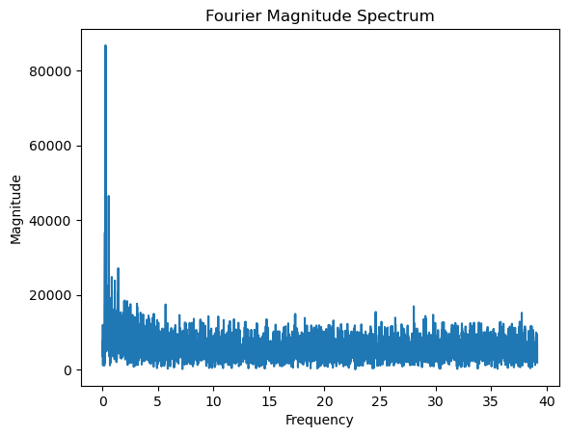

An option that is available to us is that we could also limit Unity’s frame rate.

# Version 2 – UFFT with Small MA smoothing

Since this is predominantly focussed on hand-tremors, if any MA smoothing is to be applied we want to ensure that the smoothing does not smooth over any potential tremors. According to this paper, ([here](https://www.ncbi.nlm.nih.gov/pmc/articles/PMC3424765/), but it links a BUNCH of other papers for this claim) standard human tremors occur between 11 and 7 Hz. However, for post-stroke patients, it appears that the tremors of concern are below 4.5Hz, being lower frequency ([source here](https://pubmed.ncbi.nlm.nih.gov/19662325/)):

Therefore, any smoothing that is applied should so that the standard hand tremors are also captured, in case an individual sees greater issues with those post stroke. Therefore, smoothing should not be greater than 11Hz.

Since we have data over seconds, we will make sure that the smoothing does not cover more than 90ms of data.

To achieve this, we make an approximation, in that we have uniform data with timestep:

Sampling_rate = Total_tlength / total_samples

Then we want to modulus divide this by 11, or

MA smoothing = ROUNDDOWN(sampling_rate / 11)

Introducing a MA smoothing with parameters above provides us with:

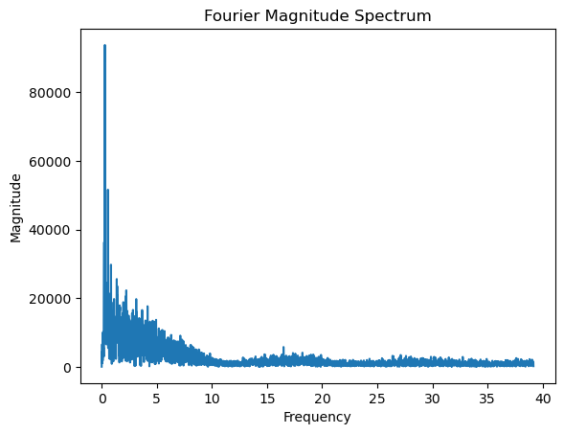

# Version 3 – NUFFT with MA Smoothing

Due to time constraints, NUFFT was not evaluated. Instead, the project opted to limit frame rate to 60FPS.

# Version 4 – FFT with More Severe MA Smoothing

Since it is known stroke-induced tremors are at a frequence of <4.5Hz, we will increase the MA smoothing window. This gives us:

Ma_smooth_param = ROUNDDOWN(60/(4.5*2)) = 13

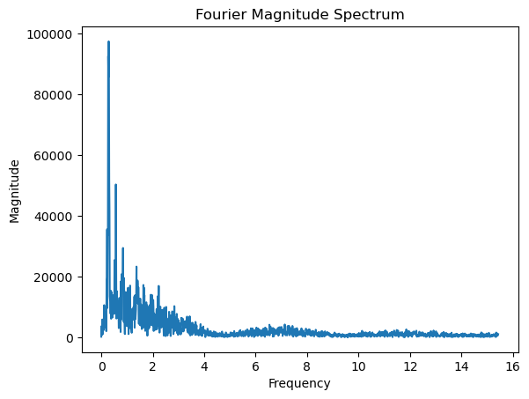

This is by far the most promising of all done. By limiting the window further to just the frequencies less than 4.5Hz:

The data still contains quite a bit of noise it seems. However, to understand the impact of this on results we will have to perform our arc-length calculation

# Computing Spectral Arc-Length

They actually apply some zero-padding to the stuff they do. Let’s try see what the fourier mag spec is like with this zero padding

Following the method outlined in the paper, we get a Fourier Magnitude Spectrum as follows:

Comparing these to the above, we can see the magnitude has dropped, but there is still quite a bit of noise here.

Expected duration of data = 33s

Amount of frames per second = 60

Amount of total angles = N = 33*60 = 1980

Total padded length = K – N

Therefore total padded length = 30788